## Drill through Steps

Actual Data:

|  |  |  |  |
| --- | --- | --- | --- |
| **TR_ID** | **Country** | **City** | **Sales** |
| T1 | India | Delhi | 400 |
| T2 | UAE | Dubai | 600 |
| T3 | India | Delhi | 600 |
| T4 | UAE | Abu Dhabi | 700 |
| T5 | India | Mumbai | 800 |
| T6 | India | Mumbai | 400 |
| T7 | UAE | Dubai | 500 |
| T8 | UAE | Abu Dhabi | 500 |

There are **2** pages in PBI.

**Page 1:**

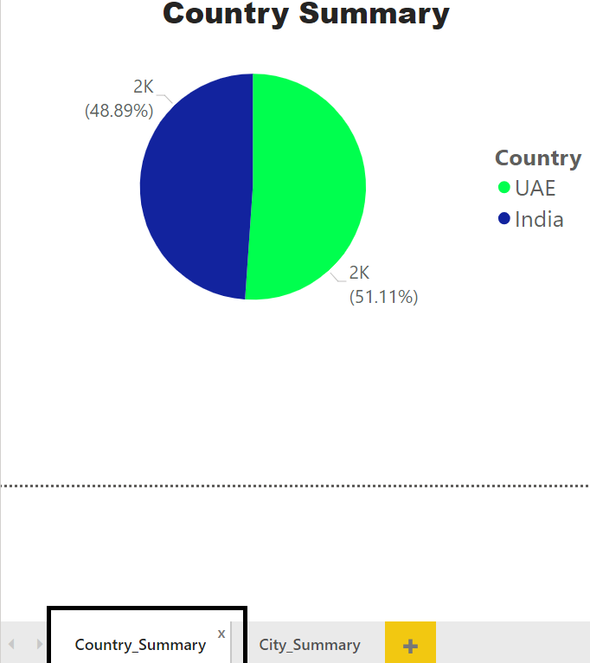

**Page 2:**

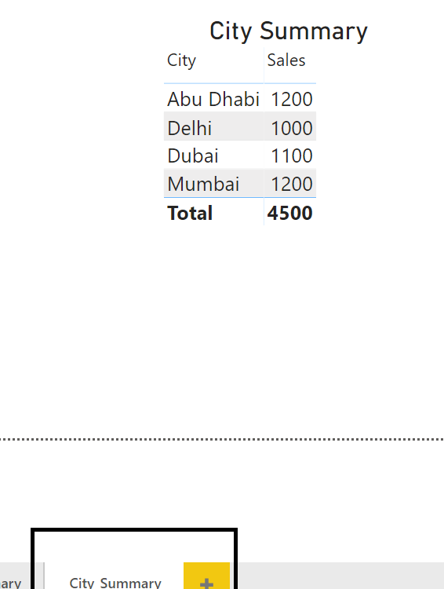

**Objective 🡪** Through Country_Summary page based on the country right clicked, it should take us to the City_Summary page and show City details of that Country only!!

***** **Drillthrough needs to be added on the Target Page**.

***** The fields to be added in the Drillthrough on the Target page should be from Source page.

So in City_Summary put **Country field** in the Drillthrough as shown next 🡪

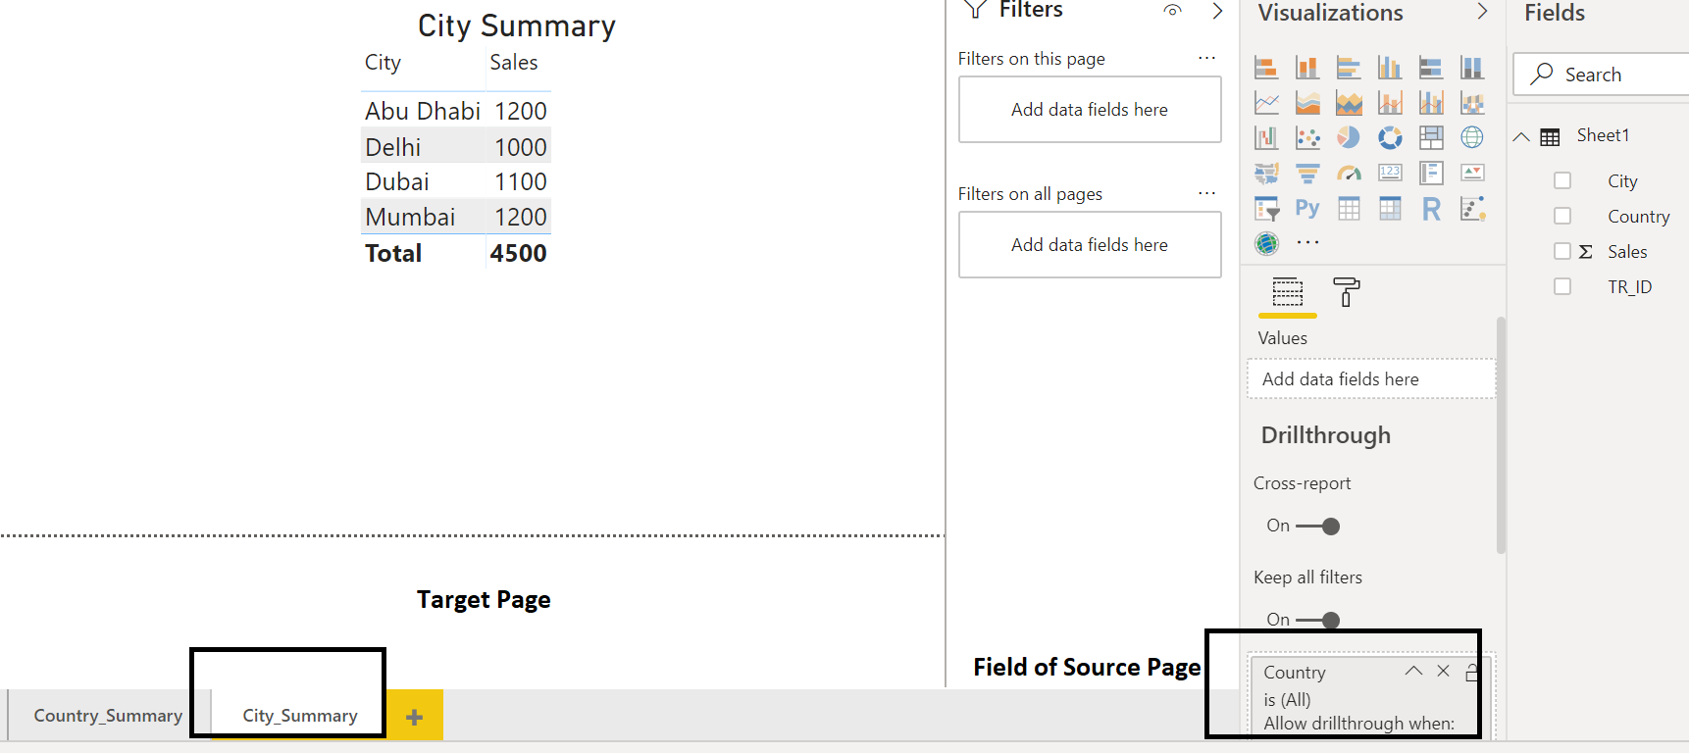

Crosschecking:

Go in the Source page, i.e. Country_Summary

R.C. in the UAE section of the pie chart and select Drillthrough 🡪 City_Summary as shown next 🡪

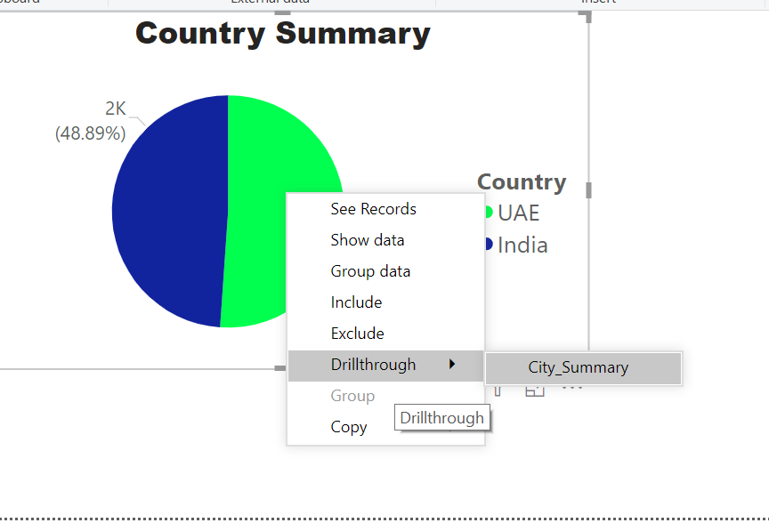

See the effect!!!

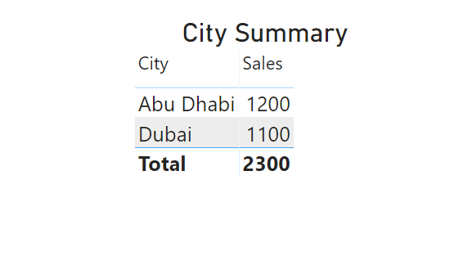

Note 🡪 There is a Back button. On **Control & Click** we can move within the pages.